package july;

import java.util.*;

class Book{

int bid,price;

String bname,author;

void accept() {

Scanner sc=new Scanner(System.*in*);

System.*out*.println("Enter BookId ");

bid=sc.nextInt();

System.*out*.println("Enter Book_Name ");

bname=sc.next();

System.*out*.println("Enter Book_Author ");

author=sc.next();

System.*out*.println("Enter Book_Price");

price=sc.nextInt();

}

void display() {

System.*out*.println("Book Id "+bid+"\nBook Name "+bname+"\nAuthor "+author+"\nPrice "+price);

}

}

public class July_19 {

public static void main(String[] args) {

Scanner sc=new Scanner(System.*in*);

System.*out*.println("Enter n");

int n=sc.nextInt();

Book []book=new Book[n];

for(int i=0;i<n;i++) {

book[i]=new Book();

book[i].accept();

book[i].display();

}

}

}

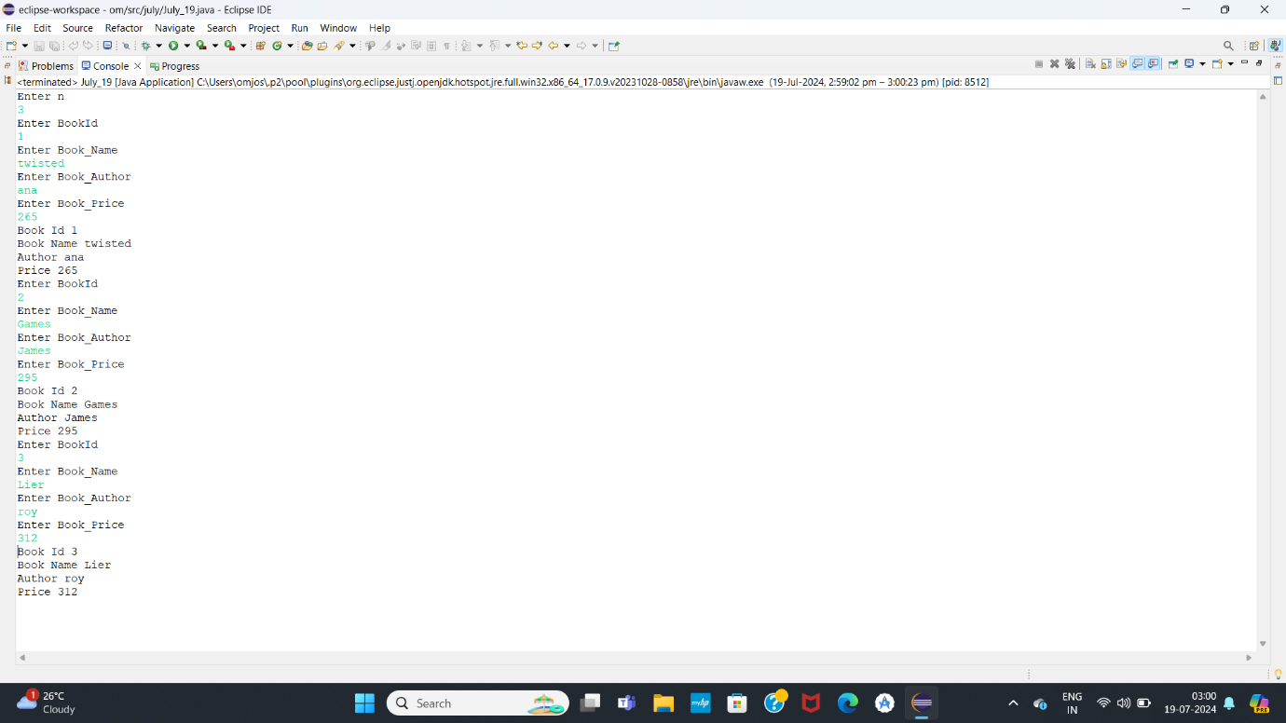

package july;

import java.util.*;

class Vehicle{

int vid;

String vname,compName,color,ownerName;

double price;

void accept() {

Scanner sc=new Scanner(System.*in*);

System.*out*.println("Enter Vehicle Id ");

vid=sc.nextInt();

System.*out*.println("Enter Vehicle Name ");

vname=sc.next();

System.*out*.println("Enter Company Name ");

compName=sc.next();

System.*out*.println("Enter Color");

color=sc.next();

System.*out*.println("Enter Owner Name ");

ownerName=sc.next();

System.*out*.println("Enter Vehicle Price");

price=sc.nextInt();

}

void display() {

System.*out*.println("Vehicle Id "+vid+"\nVehicle Name "+vname+"\nCompany "+compName+"\nColor "+color+"\nOwwner "+ownerName+"\nPrice "+price);

}

}

public class July_19 {

public static void main(String[] args) {

Scanner sc=new Scanner(System.*in*);

System.*out*.println("Enter n");

int n=sc.nextInt();

Vehicle []vehicle=new Vehicle[n];

for(int i=0;i<n;i++) {

vehicle[i]=new Vehicle();

vehicle[i].accept();

vehicle[i].display();

}

}

}

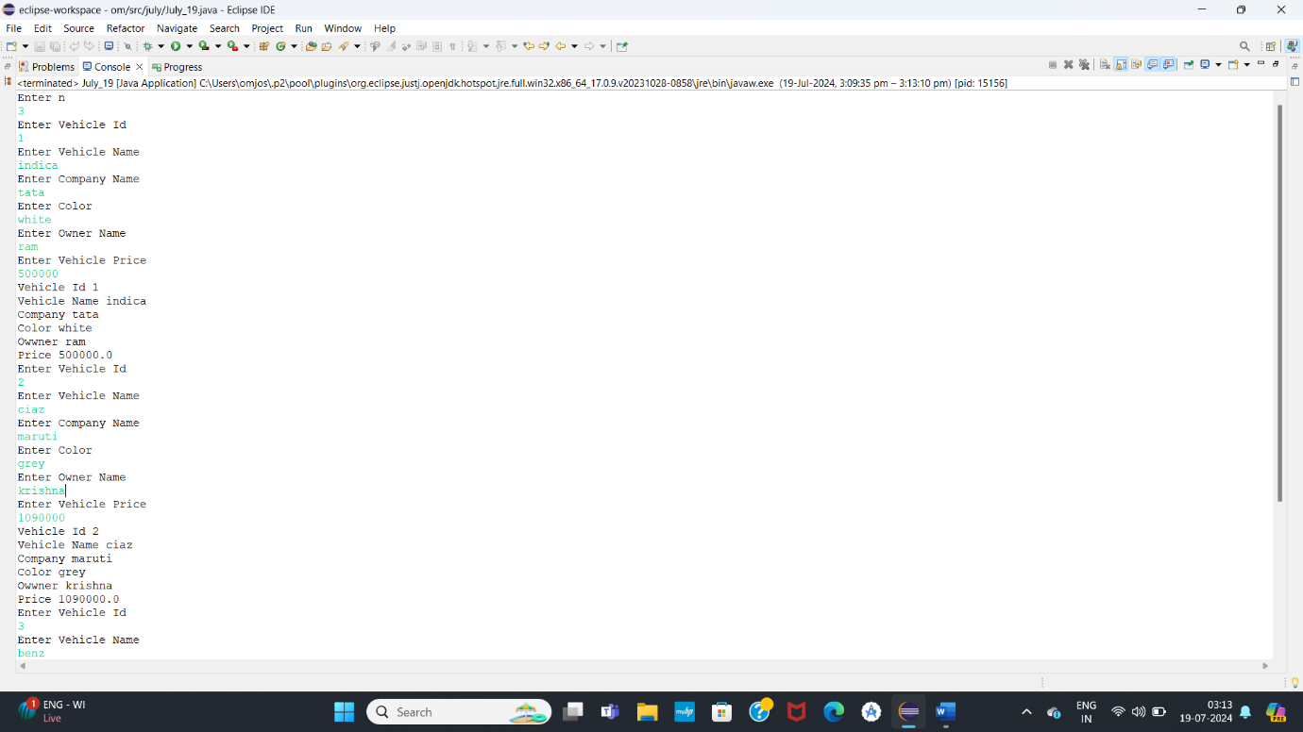

package july;

import java.util.*;

class Employee{

int eid;

String ename,designation;

double salary;

void accept() {

Scanner sc=new Scanner(System.*in*);

System.*out*.println("Enter Employee Id ");

eid=sc.nextInt();

System.*out*.println("Enter Employee Name ");

ename=sc.next();

System.*out*.println("Enter Designation ");

designation=sc.next();

System.*out*.println("Enter Salary");

salary=sc.nextDouble();

}

void display() {

System.*out*.println("Employee Id "+eid+"\nEmployee Name "+ename+"\nDesignation "+designation+"\nSalary "+salary);

}

}

public class July_19 {

public static void main(String[] args) {

Scanner sc=new Scanner(System.*in*);

System.*out*.println("Enter n");

int n=sc.nextInt();

Employee []employee=new Employee[n];

for(int i=0;i<n;i++) {

employee[i]=new Employee();

employee[i].accept();

employee[i].display();

}

}

}

